**PRACTICAL NO.10**

**Programming threads, handles and asynchronized programs**

**Code:**

**activity_main.xml**

<?xml version="1.0" encoding="utf-8"?>  
<androidx.constraintlayout.widget.ConstraintLayout xmlns:android="http://schemas.android.com/apk/res/android"  
 xmlns:app="http://schemas.android.com/apk/res-auto"  
 xmlns:tools="http://schemas.android.com/tools"  
 android:layout_width="match_parent"  
 android:layout_height="match_parent"  
 tools:context=".MainActivity">  
  
 <TextView  
 android:layout_width="wrap_content"  
 android:layout_height="wrap_content"  
 android:text="Hello World!"  
 app:layout_constraintBottom_toBottomOf="parent"  
 app:layout_constraintEnd_toEndOf="parent"  
 app:layout_constraintStart_toStartOf="parent"  
 app:layout_constraintTop_toTopOf="parent" />  
  
</androidx.constraintlayout.widget.ConstraintLayout>

**MainActivity.kt**

package com.example.mythread  
import androidx.appcompat.app.AppCompatActivity  
import android.os.Bundle  
import android.util.Log  
class MainActivity : AppCompatActivity() {  
 override fun onCreate(savedInstanceState: Bundle?) {  
 super.onCreate(savedInstanceState)  
 setContentView(R.layout.activity_main)  
 var runThread= Runnable {  
 for (m in 0..10){  
 var num=Math.random()  
 Log.d("Random Number","Random Number is : $num")  
 Thread.sleep(2000)  
 }  
 }  
 var th=Thread(runThread)  
 th.start()  
 }  
}

**Output:**

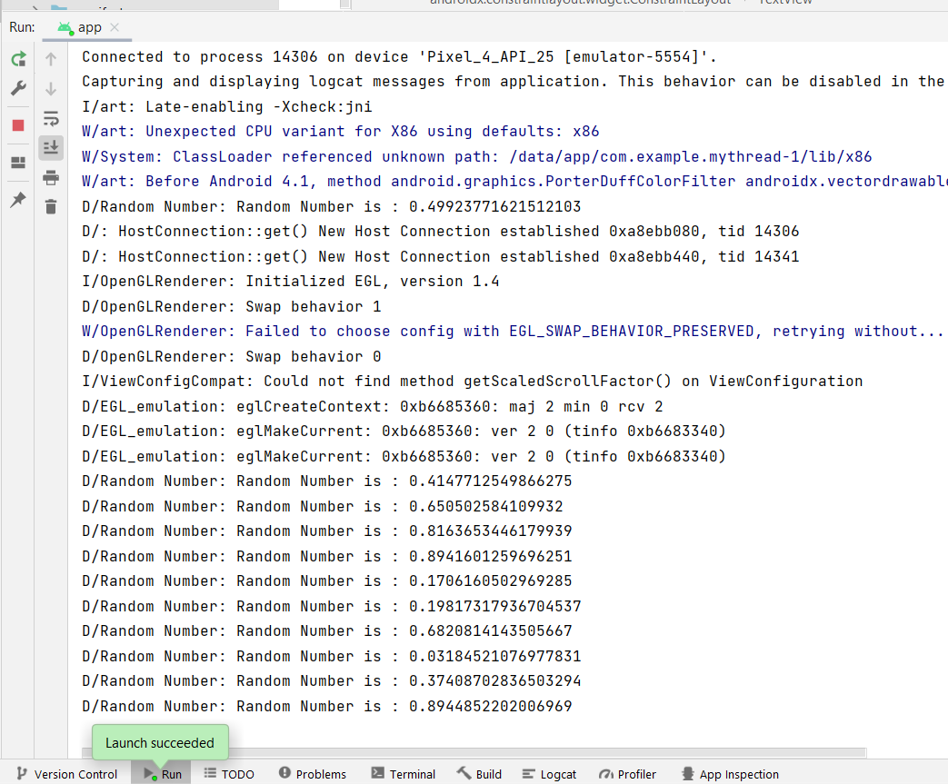

**Asynchronized program:**

**Code:**

**activity_main.xml**

<?xml version="1.0" encoding="utf-8"?>  
<androidx.constraintlayout.widget.ConstraintLayout xmlns:android="http://schemas.android.com/apk/res/android"  
 xmlns:app="http://schemas.android.com/apk/res-auto"  
 xmlns:tools="http://schemas.android.com/tools"  
 android:layout_width="match_parent"  
 android:layout_height="match_parent"  
 tools:context=".MainActivity">  
  
 <ImageView  
 android:id="@+id/imageView"  
 android:layout_width="207dp"  
 android:layout_height="208dp"  
 app:layout_constraintBottom_toBottomOf="parent"  
 app:layout_constraintEnd_toEndOf="parent"  
 app:layout_constraintStart_toStartOf="parent"  
 app:layout_constraintTop_toTopOf="parent"  
 app:layout_constraintVertical_bias="0.195"  
 app:srcCompat="@drawable/ic_launcher_background" />  
</androidx.constraintlayout.widget.ConstraintLayout>

**MainActivity.kt**

package com.example.myasync  
class MainActivity : AppCompatActivity() {  
 private lateinit var imageView: ImageView  
  
 override fun onCreate(savedInstanceState: Bundle?) {  
 super.onCreate(savedInstanceState)  
 setContentView(R.layout.activity_main)  
 imageView = findViewById(R.id.imageView)  
 SetImage(imageView).execute("https://upload.wikimedia.org/wikipedia/commons/thumb/d/d7/Android_robot.svg/1745px-Android_robot.svg.png")  
 }  
 public inner class SetImage(var imgView: ImageView ):AsyncTask<String,Void,Bitmap?>(){  
 init {  
 Toast.makeText(applicationContext,"Image is Loading",Toast.LENGTH_LONG).show()  
 }  
  
 override fun doInBackground(vararg p0: String?): Bitmap? {  
 var imgUrl=p0[0]  
 var img:Bitmap?=null  
 try {  
 val inn=java.net.URL(imgUrl).openStream()  
 img=BitmapFactory.decodeStream(inn)  
 }catch (e:Exception){}  
 return img  
 }  
  
 override fun onPostExecute(result: Bitmap?) {  
 imgView.setImageBitmap(result)  
 }  
 }  
}

**Add at AndroidManifest.xml:**

<uses-permission android:name="android.permission.INTERNET"/>

**Output:**

